Light and Color Student Worksheet
Name: _____________________________________________________________________________________________________
Group members: _____________________________________________________________________________________________

PHENOMENON: Animals throughout the ocean depths are different colors and use different colors of bioluminescence. Why? How?

BEFORE THE LESSON
1. When you picture a fish, whale, or shark at the surface of the ocean, what color(s) are their bodies?
Why do you think that is the case?

2. What colors do you think animals like fish, sea stars, etc., are deeper in the ocean where there is less light?

3. What about in the deepest parts of the ocean where there is no light? Do you think they are different colors or the same
colors as the surface?

4. What questions do you have about color and organisms in the deep ocean at this point?

GUIDED IMAGERY
5. What did you think/see in your mind during the story about going into the ocean?

6. How can we model going into the deeper ocean? Record your ideas and ideas from the class discussion.

7. What observations did you make while exploring the layers of blue film?

PREDATION INVESTIGATION
Prediction/Hypothesis: If we simulate going into the deep ocean, then (select a color) prey will be the most camouflaged and will be eaten less than the other colors.

Results
Record the number of prey “eaten” in each round when you use one layer of blue film.
ROUND | Red | Orange | Yellow | Green | Blue | Purple | White | Black
1
2
3
4
TOTAL

Prediction/Hypothesis: If we simulate going into the deep ocean, then (select a color) prey will be the most camouflaged and will be eaten less than the other colors.

Results
Record the number of prey “eaten” in each round when you use three layers of blue film.
ROUND | Red | Orange | Yellow | Green | Blue | Purple | White | Black
1
2
3
4
TOTAL

8. What patterns do you see in the data collected? Do some colors get “eaten” more or less than others?

9. What was the impact of using 1 vs. 3 layers of blue filter paper over your eyes? What aspect of the ocean did adding
layers of filter paper model?

10. Do your results support your prediction/hypothesis? Why or why not?

LIGHT AND WAVELENGTHS
11. During the rope demonstration, what did you learn?
a. Label this diagram with the terms amplitude, wavelength, crest, trough

b. Write a few sentences describing what you learned about the relationship between energy and wavelength?

12. Look at the graphic of a prism. What patterns can you see with the relationship between color and wavelength?
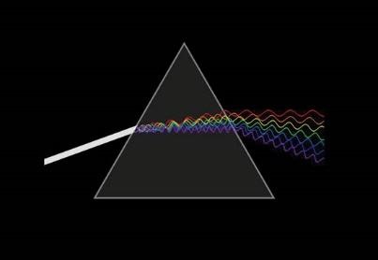
13. What conclusions can you draw then about the relationship between color and energy?

DRAWING CONCLUSIONS
14. Look back at your results of the predation investigation and what you learned about color, wavelength, and energy. What
color do you think is far more common in the deeper ocean than in other parts of the ocean or on land? Why? What does it
provide for those organisms?

BIOLUMINESCENCE
15. While watching the video on bioluminescence, record your observations/thoughts on:
a. the colors of light created by deep sea organisms

b. the purposes of bioluminescence

c. other observations

16. What questions do you have after watching the video?

17. What conclusions can you draw about the color of bioluminescence most commonly used in the deep ocean? Why?

WHAT DID YOU LEARN?
18. On a separate paper (or on the back of this paper), draw a model of what you learned about the phenomenon:
Animals throughout the ocean depths are different colors and use different colors of bioluminescence. Why? How?
Include an animal of your choosing (real or imaginary) at the surface and at depth. Your diagram should include as many of
these terms as possible: depth, wavelength, blue, red, bioluminescence. It must also include both what color(s) the
organism is and what color(s) it appears at the depth you place it.

